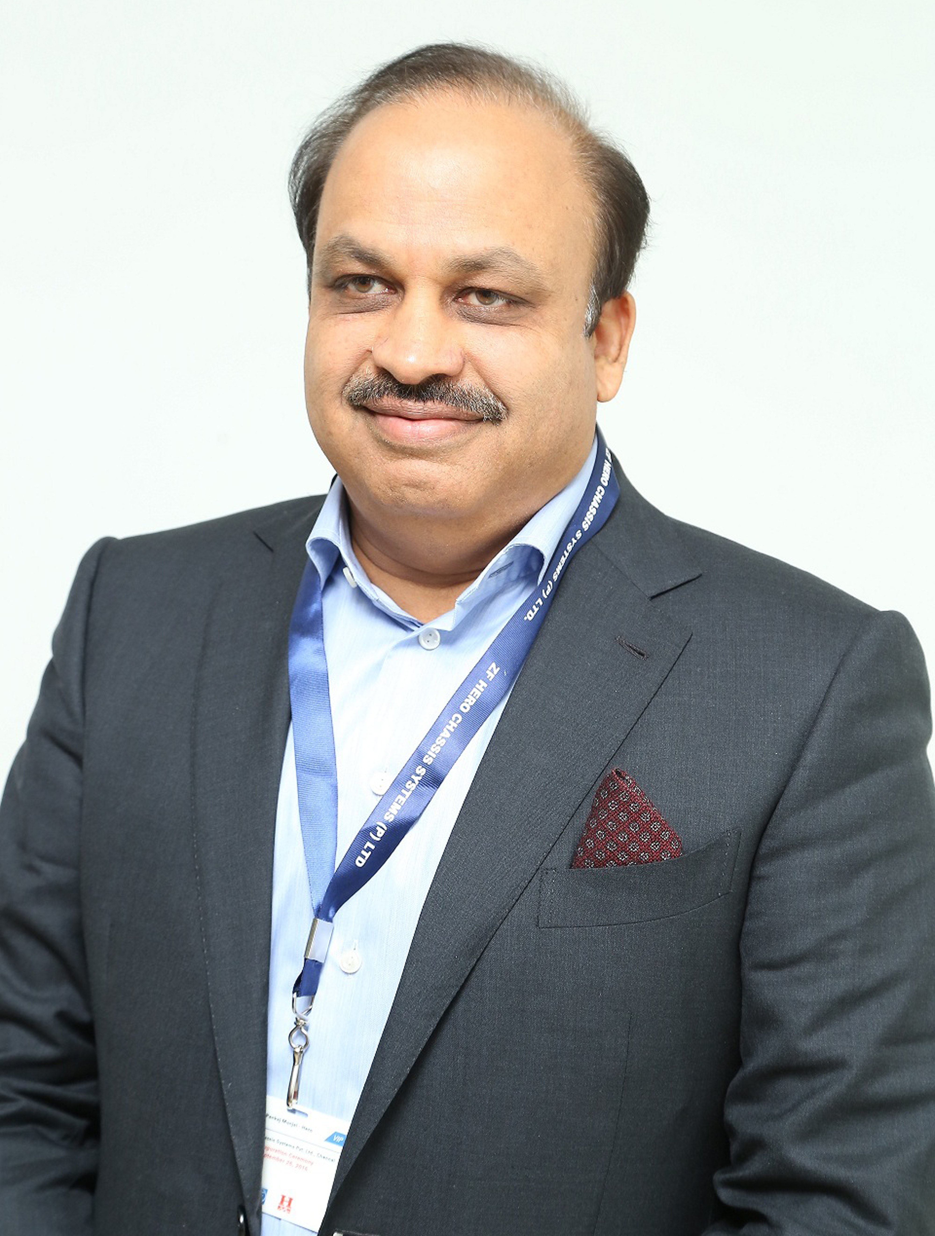
Profile of Mr. Pankaj Munjal
Born into the family of the Munjals, the founders of the Hero Group, love for automobiles was in the blood of Mr Pankaj Munjal. But being the second generation of a business leadership, he faced challenges that come with the growth of a longstanding business – the challenges of how to make sure the business keeps finding new ventures and greener pastures and does not plateau.
In preparation to take up the business of the Hero Group, Mr. Munjal graduated in Science and then studied Automotive Manufacturing at General Motors Institute, Flint in USA. Thereafter, he attended the executive program in Strategic Marketing Management at London Business School, Harvard University.
Through his education and study of business, there was one aspect he came to believe in strongly – the need for constant upgradation of knowledge and technology. Over the years he has made sure that any new management concept, any new development in automotive technology and any new chance of expansion does not go unstudied by him.
Mr. Pankaj Munjal serves as the Co-Chairman & MD of Hero Cycles Ltd. and the Managing Director of Hero Motors Ltd. ‘By constantly bringing in new thoughts and experiences’ is how he runs the organization today.
He has been instrumental in shaping the Hero Cycles consumer-driven strategy by introducing various new strategic initiatives. Amongst his special focus areas in bicycle industry are technology upgradation, development of cycling infrastructure and economical mobility to the disadvantaged.
On the automotive front, he is leading Hero Motors Ltd. to target the global automotive market with gears and transmission components for international customers like BMW, Bombardier, Harley Davidson etc. He is also present in the domestic automotive market with group companies - Munjal Kiriu Industries Pvt. Ltd. and ZF Hero Chassis Systems in joint venture with Sumitomo Kiriu of Japan and ZF of Germany respectively.
While the story of his father, Mr O P Munjal, is one of a rise of a nobody who made his own way in the midst of changing times and crumbling old edifices, Mr Pankaj Munjal’s story has been that of challenges to maintain the rise of a successful business venture and constantly outthink the competitors.
To nurture new leadership and out-of-the-box thinking, he has incorporated several ideas into the group’s way of functioning. His company Hero Motors, a part of the Rs.102 billion Hero group, sends its employees regularly to London Business School (LBS) and to ISB (Indian School of Business) in India for training.
Under his leadership, while Hero Honda has decided as a strategy to concentrate on the two-wheeler segment, Hero Motors has become the engineering outsourcing base of the group servicing auto-ancillary outsourcing requirements of companies like GM and Ford and boosting engineering exports from the country. His vision is essentially global as he always thinks of the way forward.
A cycling and biking enthusiast to the core, Mr Munjal campaigns for creating cycle friendly cities and empowering the masses of the country with the ubiquitous two wheeler.

